**Report of Confusion Matrix of Tone Analyzer API**

#### Overview

We are team 12. And I wrote this report to draw the confusion matrices for our analyzer API. Because we do not need to train our model, we can directly use a part of the raw data as the training dataset. We do not need to split that set to training set or validation set. Our training data is based on the Chinese lyrics scraping from the website [10]. We cannot make the raw emotional tag for the dataset. So, we choose a small scaled dataset to add the tag manually. As for the testing data set, I just choose the dataset posted on the gituhub: https://github.com/rasbt/musicmood/blob/master/dataset/validation/valid_lyrics_200.csv

#### Matrix of training data



Above is the training dataset.

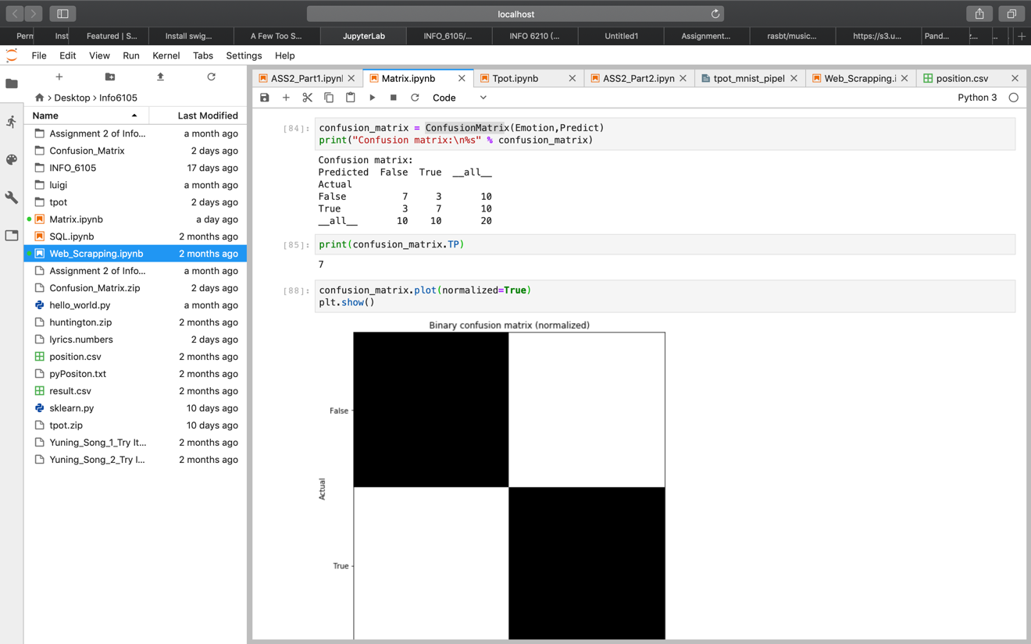



According to the above code, the F-1 score of the training data is about 0.7.

#### Matrix of testing data

Below is the raw data of testing data.

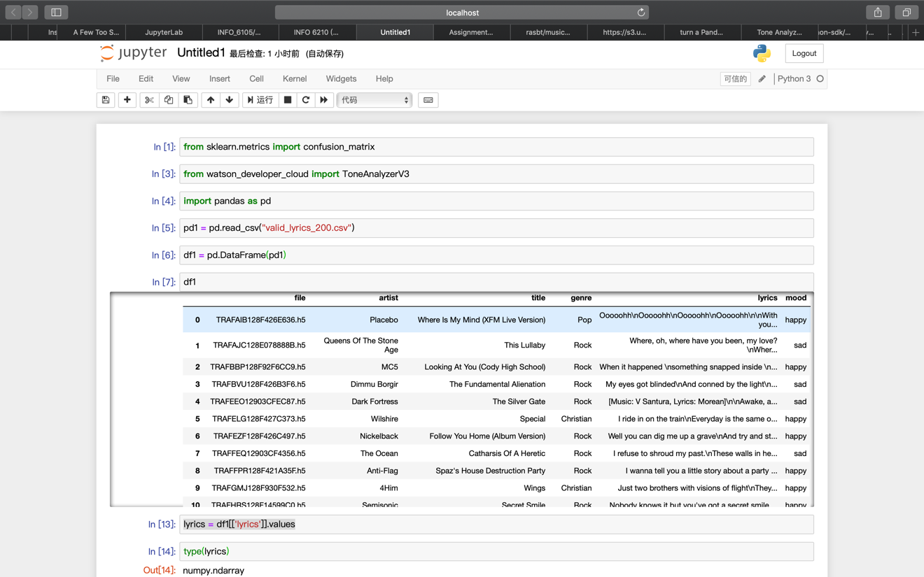

Next is the process of getting emotion array

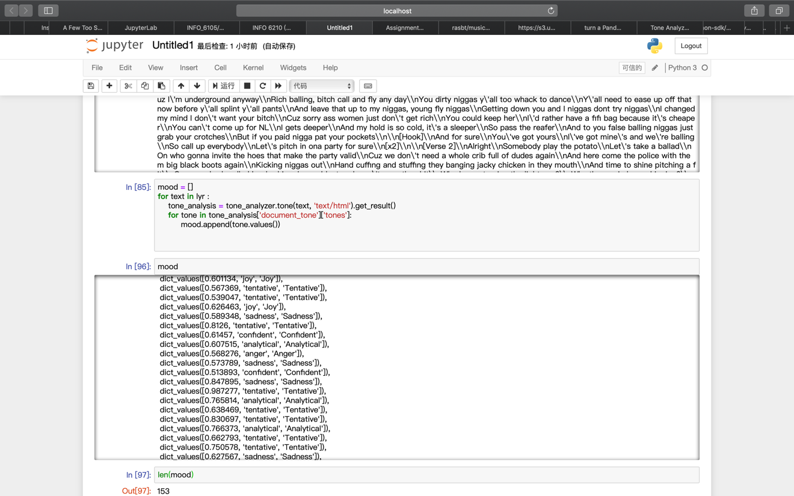

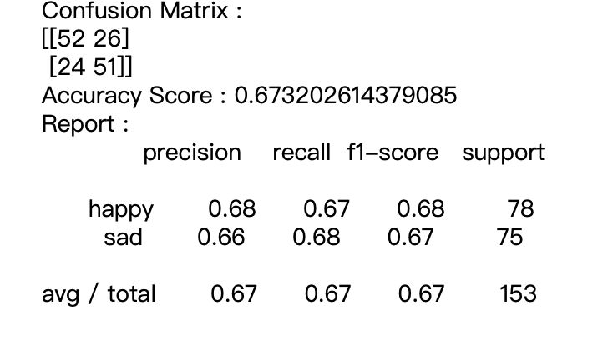

According to the above matrix, our accuracy is 0.67. Average F1 score is 0.67.

The total valid data is 153 rows but not 200 rows. That’s because our API will come out with a multi-emotional result that contains not only happy and sad, but also “fear”, “confidence”, “analytical” and “tentative”. It is hard to just classify the result into happy and sad. I just choose useful results for the processes.

#### Computing both of above data sets

The results of the both datasets show that the training process is better than the testing process. Because the accuracy of training process is 0.7. But the testing accuracy is around 0.67. But I think this difference is within a reasonable range.

#### Computing the F-1 score

The F-1 Score of training process is a little bit higher than the testing process. Firstly, I expect the testing score will be higher than the training score. Because the API was built based on English. In other words, we will obviously get a higher score if we use English song to do the prediction. But the truth is that our lyrics in training set has been put through out a translate API. The emotion and the tone of the lyrics may change because of that process. But our training data is so small. I think if the dataset is big enough, the above influence is more visible. Secondly, it is really confused that to classify the 6-parameter output to a single happy-sad output. There might be some error classification and some misleading of tags. Finally, I think not only the F1 score but also the performance of the both processes are pretty similar.

#### Conclusion

The tone analyzer API can classify the input text to different emotion like joy, fear, sadness, anger, analytical, confident and tentative. The performance of the API is obviously higher than the result of our experiment. We just classify the emotion to sad and happy, although the emotion like analytical is a really tricky part and hard to define. In other words, the API is a really precise and effective process while testing. If we see each score of their prediction inside the results. We can see if there is a prediction, the score must be higher than 85%. If we set the method into a status that is more suitable for the method, I think it will output a high accuracy and F1 score about the predictions.